|  |
| --- |
| **Phoenix - solution to web** |
| **Universal Adventure** |
| Arcade Game  logo |
| Version 2.0  All work Copyright © 2014 by Phoenix Games.  All rights reserved. |
| **Krunalsinh Parmar**  **Bhaumik Patel** |
|  |

|  |
| --- |
| Dec 12th 2014 |

**Table of Contents**

|  |  |  |
| --- | --- | --- |
| **SR.** | **CONTENT** | **PAGE** |
| **1** | [VERSION HISTORY](#vh) | **3** |
| **2** | [GAME OVERVIEW](#go) | **4** |
| **3** | [GAME PLAY MECHANISM](#gpm) | **4** |
| **4** | [SCREEN DESCRIPTION](#SD) | **4** |
| **5** | [CONTROL](#ctrl) | **7** |
| **6** | [INTERFACE SKETCH](#is) | **7** |
| **7** | [VEHICLE](#ff) | **9** |
| **8** | [ENIMIES](#ENMY) | **10** |
| **9** | [SCORING](#SCORE) | **10** |
| **10** | [SOUND INDEX](#SOUND) | **10** |
| **11** | [ART/MULTIMEDIA INDEX](#IMG) | **10** |

**Version History**

**Version 1.0:**

Initial Commit in which simple index html page created and set to local directory. Write code for simple slider logic to validate work environment of game.

**Version 1.1:**

Create CSS and Java Scripts to add more feature to game play option, replaced text logic with image to verify flexibility of logic throughout the game. Also fix some error regarding image display and game restart.

**Version 1.2:**

Modify game to work with collision effect and improve response time to avoid slow response on game progression, working on LTR (Left to Right) panel transition.

**Version 1.3:**

Final version created with full functionality as per current requirement and made modification to background image and plane image (main character).

**Version 1.4:**

Working version created with full functionality as per current requirement and change islands with hearts create new atlas for game replace with old one to compatible it with new layout of game points are now collected by engaging with heart. Working on levels.

**Version 2.0**

In this level we expand game to 3 level player have to finish all 3 levels to win this game. All three levels are inter connected. When player win first level directly jumps in level 2. After achieving all achievements player will jumps in final level in final level player has to collect space ball as a achievement.

1. **Game Overview**

When player load game to play he will get home page of the game in this page player can find 2 options 1.Start game, 2. Instruction.

1. Start game

In the start game player can go to play game

1. Instruction

This option direct to how to play section in this section player will get all detail about how to play game gives instruction about details about all levels.

In all level player can move his vehicle according to mouse pointer. Player can use weapons of the vehicle with the left click of mouse.

1. **Game Play Mechanics**

Main screen has two option “start game” and “Instruction”, read instruction before you start first time. When you click on start you have control of plane with your mouse left click will be use as trigger for firing weapons to kill enemy. You can go forward and move backward to get points and dodge enemy.

1. **Screen description**
2. **Start screen:-**

**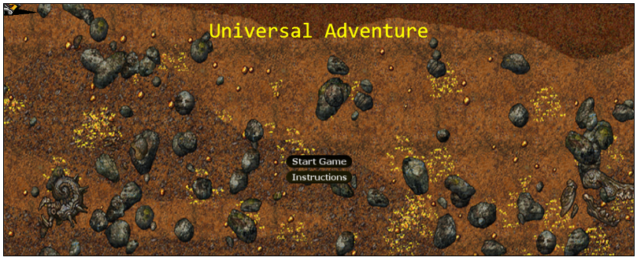**

1. **Instruction:-**

**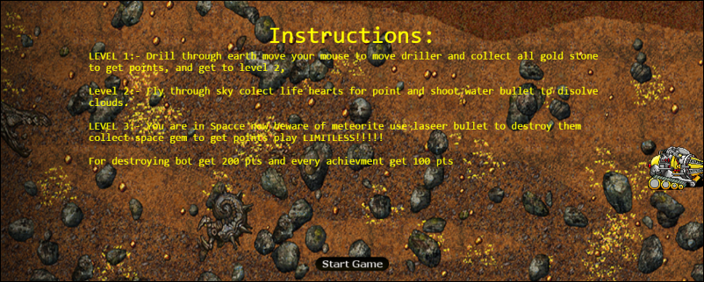**

**Level 1 (Under Ground) Screen Shots**

1. **Collect Points**

**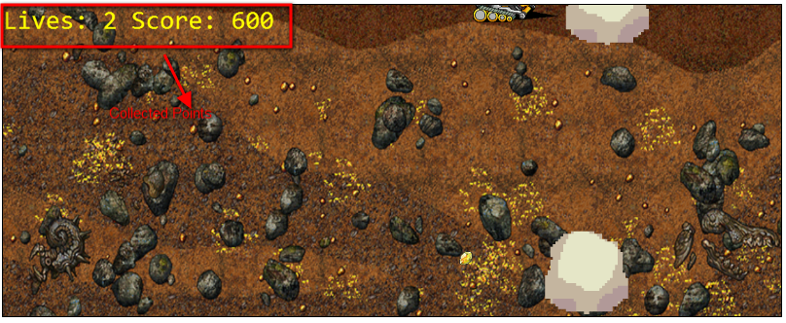**

1. **Toxic Gas collision:-**

**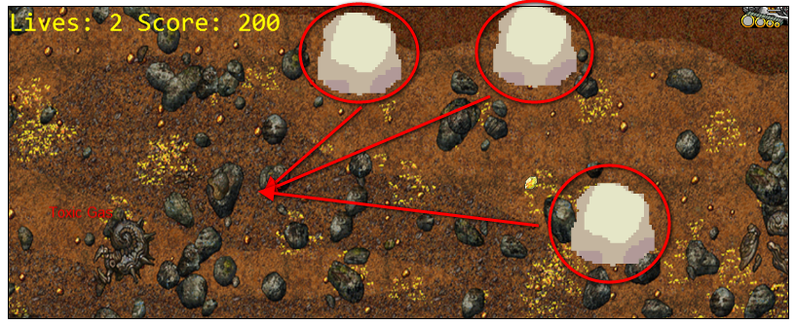**

**Level 2 (Sky) Screen Shots**

**1 Collect Points**

**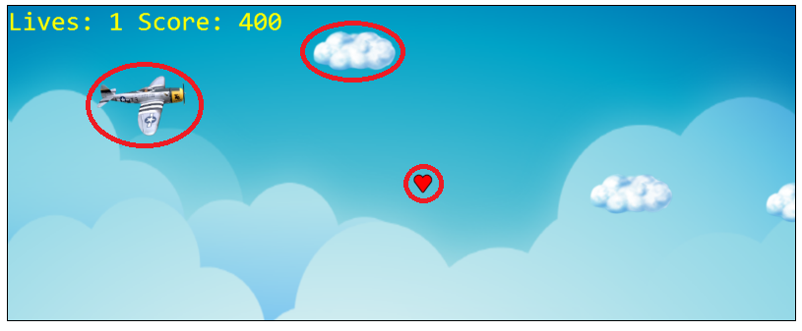**

In this screen shots.

1. Hearts: This are the points which are player has to collect.

2. Plane: This is player’s vehicle.

3. Clouds: This are the enemy for the player. Player has to save himself from this enemy

**Level 3(Space) Screen shots**

**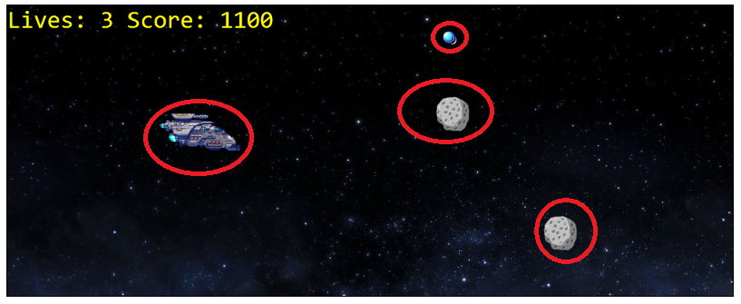**

1. Space Ball: Player has to collect this space ball to get points.
2. Asteroids: This are the enemy of space ship player has to save himself from this.
3. Space ship: In this level player will fly in spaceship.

**Game over Screen**

**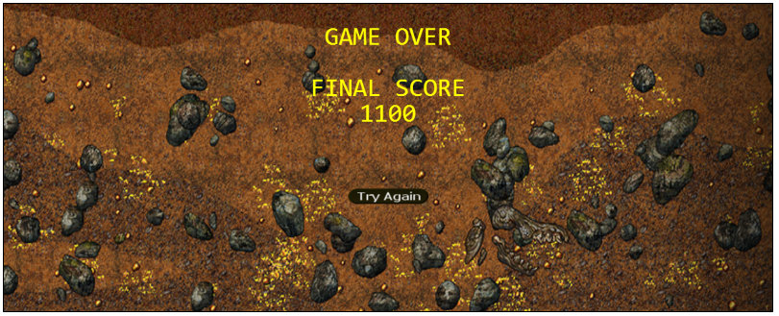**

1. **Controls**

Game is Design to play on website, which is why you can control all the feature using mouse. You will only able to control plane not any other environment on game panel.

1. **Interface Sketch**
2. **Start Screen:**

**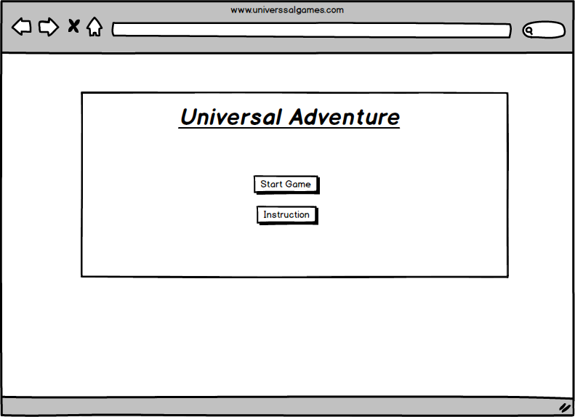**

1. **Instruction Screen: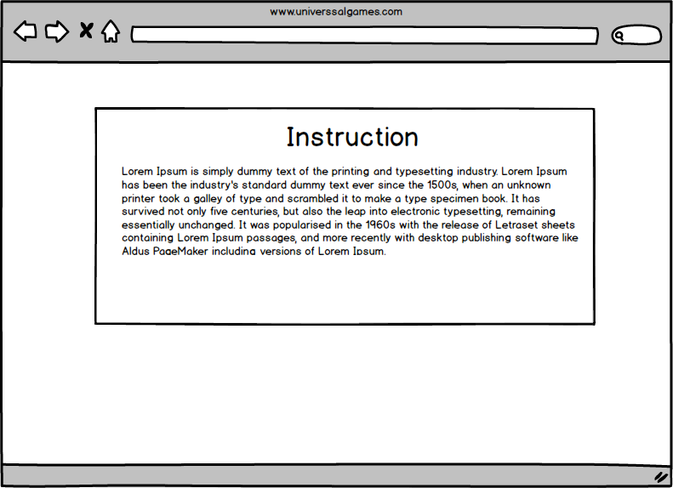**
2. **Game Play Screen: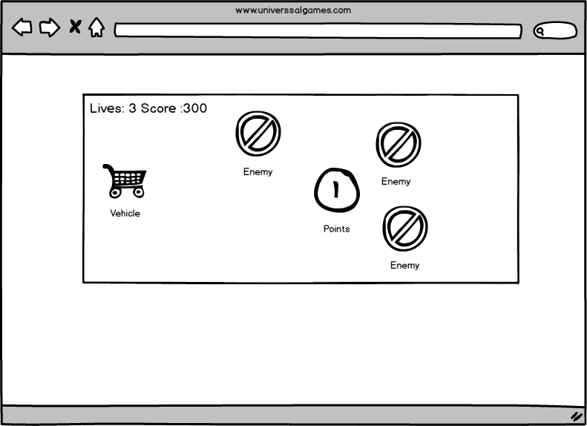**
3. **Game End Screen:**

**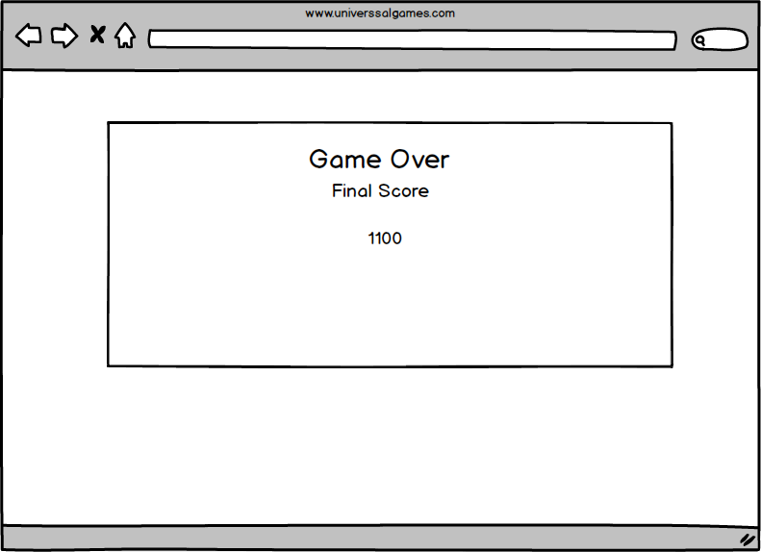**

1. **Vehicles**

**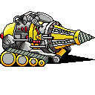 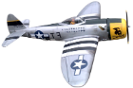**

These are the main characters of the game which is controlled by player using mouse, all of the vehicles are fully equipped with weapons. All of them can fire the weapons to save them self from enemy and collect points.

1. **Enemies**

** **

These are the enemies of this game.

**Level 1 (Toxic gas)**

This is toxic gas it is highly and highly flammable.it can kill drive and burn the vehicle so our driver has to burn that gas from far away. After bun gas will reduce his poison. Player can burn the gas with fire bullets.

**Level 2 (stormy Clouds)**

Stormy clouds are dangerous for the plane it can damage all electric equipment of the plane and plan can be out of control.to save our plane from this clouds player has to fire water bullets. Water can dissolve clouds.

1. **Scoring**

**E:\Games\universal adventure\MailPilotAssign3\MailPilotAssign3\assets\images\island1.pngE:\Games\universal adventure\MailPilotAssign3\MailPilotAssign3\assets\images\island2.pngE:\Games\universal adventure\MailPilotAssign3\MailPilotAssign3\assets\images\island3.gif**

This are the scoring points of the game player has to collect them in each and every level.

1. **Sound Index**

|  |  |  |
| --- | --- | --- |
| **Sound file name** | **Format** | **Description** |
| Background | .wav | Plays throughout the game |
| Thunder | .wav | Plays each time enemy struck plane |
| Space\_powerup | .wav | Plays each time point collected |
| Space\_shot | .wav | Plays when bullet fired |

1. **Art Media Index**

|  |  |  |
| --- | --- | --- |
| **Image** | **Format** | **Description** |
| E:\Games\universal adventure\MailPilotAssign3\MailPilotAssign3\assets\images\blueprint.png | .png | Sprite sheet for entire game image. |
| E:\Games\universal adventure\MailPilotAssign3\MailPilotAssign3\assets\images\bullet2.pngE:\Games\universal adventure\MailPilotAssign3\MailPilotAssign3\assets\images\bullet3.png | .png | Bullets fire by Vehicle. |
| E:\Games\universal adventure\MailPilotAssign3\MailPilotAssign3\assets\images\cloud2.pngE:\Games\universal adventure\MailPilotAssign3\MailPilotAssign3\assets\images\cloud_2.pngE:\Games\universal adventure\MailPilotAssign3\MailPilotAssign3\assets\images\cloud3.png | .png | Computer operated enemies. |
| E:\Games\universal adventure\MailPilotAssign3\MailPilotAssign3\assets\images\island2.pngE:\Games\universal adventure\MailPilotAssign3\MailPilotAssign3\assets\images\island1.pngE:\Games\universal adventure\MailPilotAssign3\MailPilotAssign3\assets\images\island3.gif | .png | These are use as points. |
| E:\Games\universal adventure\MailPilotAssign3\MailPilotAssign3\assets\images\plane2.pngE:\Games\universal adventure\MailPilotAssign3\MailPilotAssign3\assets\images\plane1.pngE:\Games\universal adventure\MailPilotAssign3\MailPilotAssign3\assets\images\plane3.gif | .png | Main avatars of game. |
| E:\Games\universal adventure\MailPilotAssign3\MailPilotAssign3\assets\images\ocean.pngE:\Games\universal adventure\MailPilotAssign3\MailPilotAssign3\assets\images\ocean2.pngE:\Games\universal adventure\MailPilotAssign3\MailPilotAssign3\assets\images\ocean3.png | .png | Backgrounds use for game platform level 1, 2, and 3. |